Project Proposal & USER PERSONAS

INFO 631 IS Design and Development



TEAM 8

APRATIM MUKHERJEE

KARTHIK SAMANTHAPUDI

KIRTHAN VASUDEVAN

MOHAMMAD ATIF TAHIR

VARUN AGGARWAL

VATSAL GUPTA

TAble of Contents

Emphasis Heading 1 1

Heading 2 1

Heading 2 2

# BUSINESS CONTEXT AND PROBLEM

It’s a common problem to share common household tasks or basic chores in small office settings. To manage this problem people either use a document to record their turns or are dependent on their brain to remember their turns. Even though there are some apps out in the market, they have not been able to win people. Most of these apps are like task manager and focuses on individual tasks.

This is where our **XXXXX** comes in. XXXXX will allow a group of users to add tasks, manage rotation, set reminders and even add penalties and rewards. By adding rewards/penalties, the web-app is aiming to establish an emotional connection with the users. Along with this there will be lot more features to make this mundane task fun and exciting. Also, the web-app will serve the needs of desktop, tablet and mobile phone users. The software will be launched as web-app initially and will be converted into mobile app based on users’ response.

# operations and database overview

The basic three operations that the web-app will offer are:

**Addition, Updating status of tasks:** Users will be able to add tasks, assign user(s) who will be responsible for that tasks, add rotation is applicable, and close the task when it is done. The task can be added by any user and the person who is responsible for the task, will be able to see that task. Once he/she has completed the task, it can be marked as complete and the person next in the list will be able to see it. There will also be a view, which will allow to see all the tasks irrespective of assignee.

**Notification/Reminder:** Based on the schedule provided by the user, the web app will be able to send emails to user(s), to remind them of their scheduled task. The user can add time to receive the reminder based on his/her time of availability. Once the user has received an email, the completion of tasks is entirely up to him/her. However, a feature can be added to remind again, like a snooze feature in alarm clock. This feature depends on the time available at the end of the project.

**Report:** The web-app will generate a report after a fixed period to track if all the tasks were completed successfully. This will throw some light on the performance of all individuals. The report can be shown as interactive graphs and based on that a user can be awarded or penalized. This will again be a setting that will allow a group to users to allow rewards/penalty to be added. The web-app will randomly select one of the rewards/penalty from the list provided and will show it to the user.

Database Design: We will be using MySQL data base. Initially, it will 4 tables from addition, update and deletion of records along with customer details.

Metadata of each table:

Customer Authentication:

|  |  |  |
| --- | --- | --- |
| Sno | Fields | Description |
| 1 | Uid(int) | Primary key to generate id for user |
|  | Name(varchar) | First name |
|  | l_name(varchar) | Last name |
|  | Email(varchar) | Email address |
|  | Password(varchar) | Password in 128 encryption |
|  | group_id(int) | House no /business office name |

Task Master: It saves the taskname along with its id

|  |  |  |
| --- | --- | --- |
| Sno | Field | Description |
| 1 | Task_name(name) | Task name provided by user |
| 2 | Task_id(int) | Task id auto generated |

Task Status: This table saves the status of each of customer

|  |  |  |
| --- | --- | --- |
| Sno | Field | Description |
| 1 | Task_id(int) | Task id |
| 2 | Login_id(int) | Connect the table with particular login user |
| 3 | Status(varchar) | Provides the status of the task |
| 2 | Due_date(date) | Saves the end date of task |

Task List: This table will be used to save the task provided by user.

|  |  |  |
| --- | --- | --- |
| Sno | Fields | Description |
| 1 | Task_id(int) | Primary key to generate id for task |
| 2 | Frequency(Number) | How many times the task will be repeated |
| 3 | Start_date(Date) | Start date of the task |
| 4 | End_date(Date) | End date of the task |
| 5 | Login_id(int) | Saves the login details of user |
| 6 | Created_by(varchar) | Detail of person who created it |
| 7 | Multiple(INt) | If task is repeated multiple times |

ER Diagram:

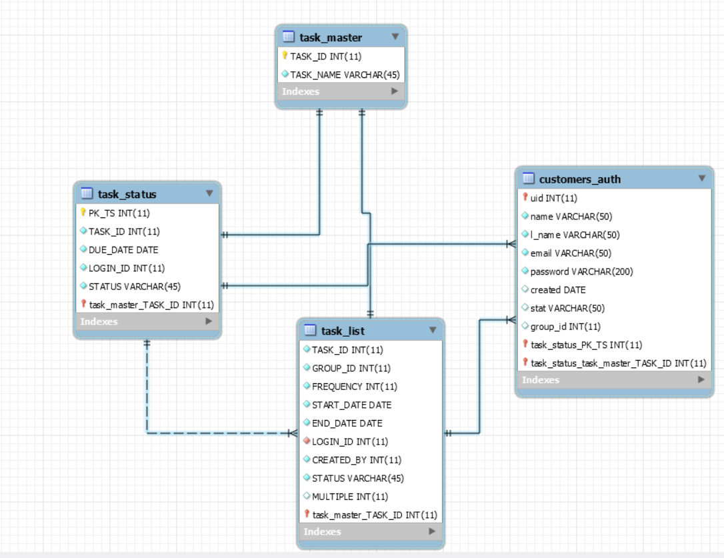

Project Expected Outcomes:

**Task addition**: User can add task with the group members and provide the start and end date in the interface. Using the business logic task will be allocated to the number of people involved in the task and individual user will be able to see the task due date and once the task is complete he/she will be able to update the status of the assigned task.

**Notification**: Assigned user will receive the email notification based on the due date so that user will be able to remember the task.

**Report**: User can generate the report for assigned dates and get the data who missed work and who completed all the work using bar charts.